**Hopscotch**

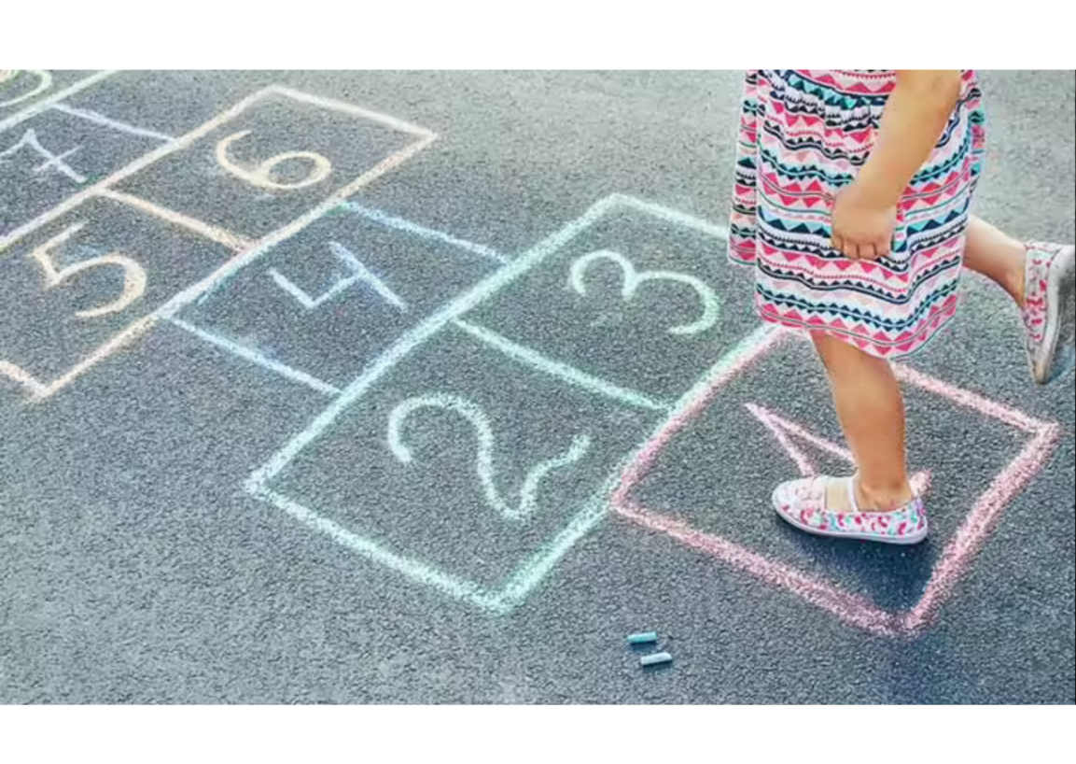

**Description**: A game where players hop through numbered squares drawn on the ground, picking up an object thrown into the squares.

**How to Play**: Draw a hopscotch grid on the ground. Players take turns tossing a small object (like a stone) onto the grid and then hopping through the squares, avoiding the square with the object.

**Location**: Sidewalk, driveway, or any paved surface.

**Things Needed**: Chalk, small object (stone or beanbag).

**Players**: 1 or more.